
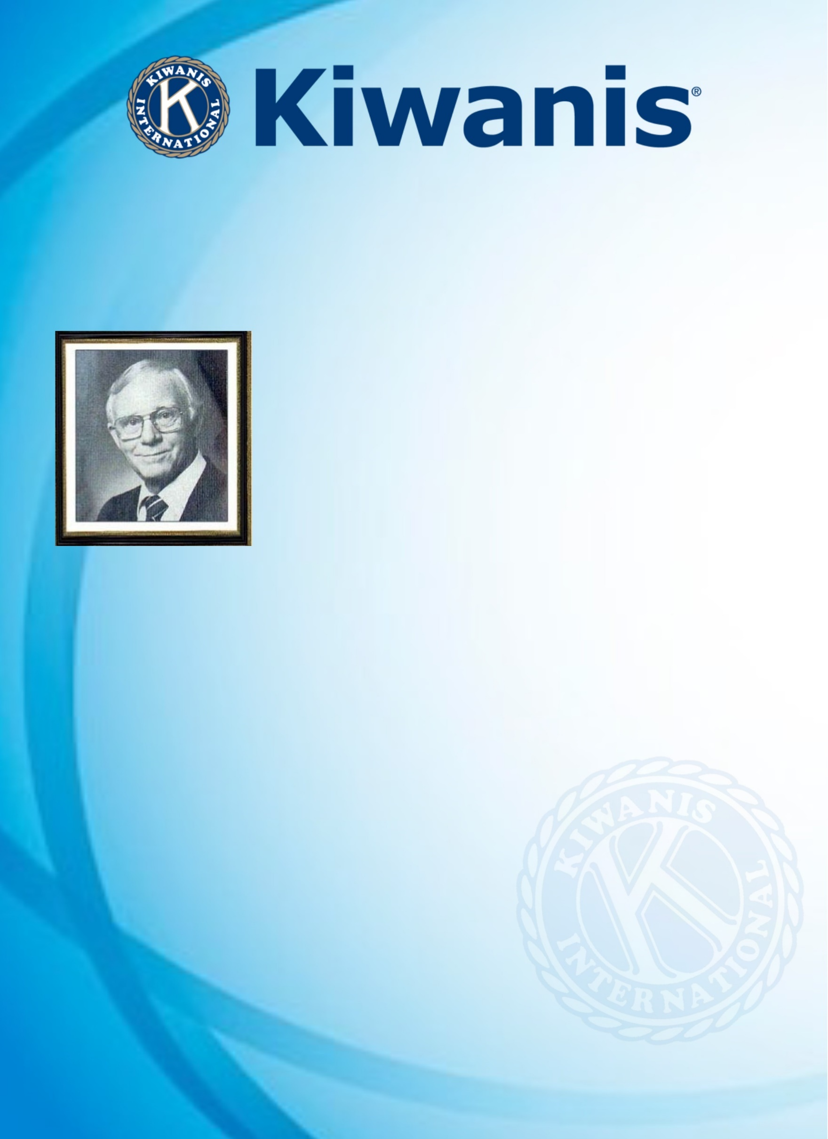
EASTERN CANADA AND THE CARIBBEAN DISTRICT

RAY ALLEN AWARD NOMINATION FORM

FOR THE ADMINISTRATIVE YEAR 2025/2026

Hailing from Division 8 (Huronia), Ray Allen served Kiwanis as EC&C Governor (1969 - 1970), 4 years as International Trustee and also International Vice President (1985 -1986). PG Ray also served as a Director and Secretary of the Kiwanis Foundation of Canada.
The Kiwanis International motto during PG Ray’s tenure as Lieutenant Governor was "Get Involved in Community Service”. The major emphasis program for his year was "Get Involved by Signiﬁcant Participation in Operation Drug Alert/ODA". This was a very successful program involving many clubs and community organizations in Eastern Canada and the Caribbean.
This award named in his honour, recognizes Outstanding Kiwanis Service by a Past Lieutenant Governor in EC&C District.

PURPOSE: To recognize Past Lieutenant Governors who continue to serve Kiwanis by contributing and participating in activities of their Club, Division and/or District, for at least 5 years after serving as Lieutenant Governor:

CERTIFICATE OF NOMINATION
This serves to certify that:

Name/PLG: LG Class of from the Kiwanis Club of
Division No.
Division Name: who joined Kiwanis on
was duly nominated at the Division Caucus/Council meeting held on at
and received a majority of the votes cast and said Nomination
is confirmed for submission to the EC&C PLG Executive Committee for Consideration.

Confirmed Signature Date
Lieutenant Governor’s Name, Signature, and date

INFORMATION ABOUT THE NOMINEE:

CLUB ACTIVITIES, PROGRAM, EVENT(S) INVOLVEMENT

AFTER SERVING AS A LIEUTENANT GOVERNOR

CLUB BOARD MEMBER (Director, VP, PE, Secretary, Treasurer, President) – YES/NO
OFFICE HELD | YEARS | ATTENDED CLUB OFFICERS TRAINING – YES/NO

CLUB COMMITTEE/PROJECT/EVENT INVOLVEMENT
COMMITTEE - EVENT NAME | YEAR(S) | CHAIR –  YES/NO

CLUB SLP KIWANIS Advisor – YES/NO
SLP CLUB FAMILY | YEAR(S) | NAME OF SLP CLUB (S)
BUILDERS CLUBS
K-KIDS CLUBS
KEY CLUBS
CIRCLE K CLUBS

OTHER CLUB INVOLVEMENT ROLES:
ROLE (S) | YES/NO | YEAR(S) | COMMENTS/EXPLANATION
BULLETIN EDITOR
PUBLIC RELATIONS
AKTION CLUB ADVISOR
KEY LEADER – PROJECT LEADER
NEW MEMBERS RECRUITED
(HOW MANY)

Additional comments: (If Necessary)

DIVISION ACTIVITIES, PROGRAM, EVENT(S) INVOLVEMENT

AFTER SERVING AS LIEUTENANT GOVERNOR

DIVISIONAL CAUCUS/COUNCIL MEETINGS Attendance Record: Number No. of Years

DIVISIONAL COMMITTEE MEMBER: YES/NO
YEAR(S) | COMMITTEE NAME | COMMENTS

DIVISIONAL COMMITTEE CHAIR: YES/NO
YEAR(S) | COMMITTEE NAME | COMMENTS

DIVISION’S PLG EXECUTIVE: YES/NO YEAR(S) DIV/TITLE DIV#

DISTRICT/INTERNATIONAL ACTIVITIES, PROGRAMS, COMMITTEES, EVENTS

AFTER SERVING AS LIEUTENANT GOVERNOR

CLE TRAINER: YES/NO Year(s) DIVISION

DISTRICT TRUSTEE: YES/NO Year(s) REGION:

DISTRICT PLG EXEC. COMMITTEE MEMBER: YES/NO Year(s) OFFICE

EC&C DISTRICT GOVERNOR: - YES/NO YEAR

DISTRICT COMMITTEE/FOUNDATION(S): YES/NO
YEAR(S) | ORGANIZATION | OFFICE | COMMENTS
DISTRICT CONVENTIONS ATTENDED: (Add list if necessary)
YEARS | LOCATION | DELEGATE YES/NO | NAME OF CLUB REPRESENTED

INTERNATIONAL CONVENTIONS ATTENDED: (Add list if necessary)
YEARS | LOCATION | DELEGATE YES/NO | NAME OF CLUB REPRESENTED

KIWANIS INTERNATIONAL COMMITTEE/FOUNDATION(S): YES/NO_____
YEAR(S) | ORGANIZATION | MEMBER/CHAIR | COMMENTS

Additional comments: (If Necessary)

ACCEPTANCE OF NOMINATION

I, PLG_________________________________ accept my nomination for EC&C’s DISTRICT PLG COMMITTEE RAY ALLEN AWARD; Year ______ and hereby verify the information for submission.

Signature and date

SUBMISSION GUIDELINES
PLEASE PDF Completed Nomination and SUBMIT to: Richard Felton
DEADLINE DATE: 11.59 PM (EST) March 31, 2026 rcfdickfelton@gmail.com

SUBMITTED BY: Lieutenant Governor:
Name

Division No (#):
Signature & Date

